8.41: Algebraically, 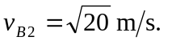 This substitution and the cancellation of common factors and units allow the equations in and to be reduced to

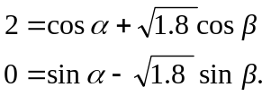

Solving for cosand sin , squaring and adding gives

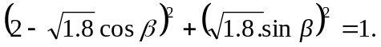

Minor algebra leads to cos 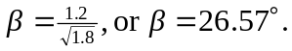 Substitution of this result into the first of the above relations gives 